

**NEWSLETTER May 31, 2020**

**Annual Meeting for June 2020**

The Board of Directors has contacted Odessa Country Club to schedule our annual meeting. Because of Covid-19 restrictions placed on them, the Club is not able to confirm a meeting date and time. Due to this uncertainty the Board has chosen to forego a meeting and simply place all documents that would be presented at the meeting on our website. All homeowners are encouraged to review these documents and submit any comments or questions via email through our website. We truly hope you understand our position on this and our concern for you and your families. Our website is [www.missionestates.net](http://www.missionestates.net)

**From the Board of Directors**

Have you even wondered what the Board does and where our dues are being used? The Board is responsible for upholding the guidelines set forth in the Covenants, Conditions, and Restrictions (CCR) established by the Mission Estates Property Owners’ Association (MEPOA). All dues are used for operation, improvement, and maintenance of the Common Properties including water bills, electric bills, sprinkler repairs, fertilization, legal fees, and administrative expenses.

**Enforcement of the CCR**

Please remember that the Board is made up of people who live in our neighborhood and care enough to volunteer their time and to serve our community. When the Board sends out a violation letter it is following the rules, performing its duty, and reminding homeowners about the rules and restrictions in the CCR that apply equally to everyone to protect our community.

**These are the most frequent violations that require letters to be sent:**

1. **Boat, RV, travel trailer, and utility trailers parked at home**

Referenced in CCR *Article VI, Section 1. Paragraph G.* No trailer, mobile home, boat, recreational vehicle, truck larger than ¾ ton, or vehicle other than passenger automobiles shall be parked, maintained, stored or kept on a Lot or Tract unless housed completely within an enclosed structure approved by the Review Board. **Approval of the enclosed structure shall be limited to those designs using materials compatible with the main structure** on the Lot or Tract and which, to the greatest extent possible, conceal the boat, trailer or vehicle from view from any street, golf course or other public areas.

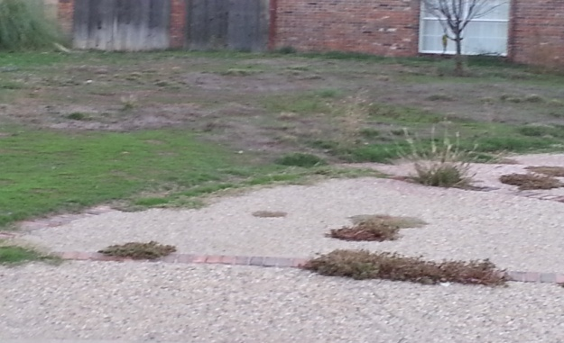 **2**. **Lawn maintenance – mowing, edging, removing weeds, trimming hedges and trees, cleaning and planting beds – maintaining property from curb to alley**

Referenced in CCR *Article VIII, Section 1* Each Owner and occupant (including any lessee of an Owner) of any part of The Properties shall jointly and severally have the responsibility, at his or their sole cost and expense, to keep that portion of The Properties so owned or occupied, including any Improvements thereon, in a well maintained, safe clean and attractive condition at all times. Such maintenance shall include, but is not limited to, the following:

a. Prompt removal of all litter, trash, refuse and waste.

b. Regular lawn mowing.

c. Tree and shrub pruning.

d. Keeping lawn and garden area alive, free of weeds, and attractive.

e. Watering.

f. Keeping parking areas, driveways and roads in good repair.

g. Complying with all government health and police requirements.

h. Repainting of Improvement.

i. Repair of exterior damage to Improvements.

1. **Construction on property with no approval from the ARB**

Referenced in CCR *Article V. Section 2.* No construction, alternation addition, modification or reconstruction of an Improvement situated upon The Properties shall be commenced or maintained, until the plans and specifications therefore and location of the same shall have been submitted to, and approved in writing by, the Review Board.

**From the Architectural Review Board**

All homeowners are required to request approval prior to any exterior modifications. This includes decks, fences, pools, outdoor kitchens and fireplaces, and roofs. We ask that you submit a to-scale drawing to the ARB for review. Jim Brown is the ARB Chairman and you may contact him at 432-556-4414.

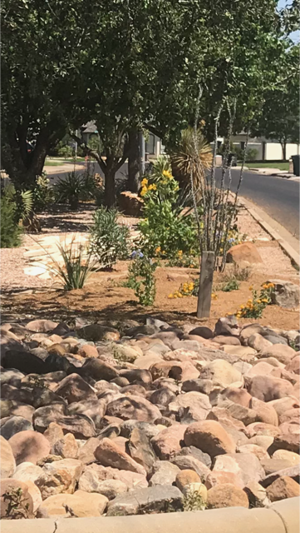

**Capital Projects**

The Board of Directors work to improve the appearance of all common areasin our neighborhood. They welcome any suggestions or recommendations you may have for future projects**.**

***JUST A NOTE***

Board meetings are held once a month. If you would like to attend, contact the Association to be informed of the time, place, and be placed on the agenda.

**2019-2020 BOARD OF DIRECTORS**

Ryan Scott Bryce Harper Garion Brunson Matt Lippman

Diego Capellini Nancy Stewart Lori Carrasco

Contact a director at our website link at [www.missionestates.net](http://www.missionestates.net) or email them at [boardofdirectors@missionestates.net](mailto:boardofdirectors@missionestates.net)

**Your input would be appreciated:**

**The Board would like to update our Covenants, Conditions, and Restrictions.** They were adopted in 1983 and have had no upgrades since. We would like to edit such things and house numbers on curbs, size of vehicles allowed to park on the street, and various other issues. We would like to have your thoughts on doing so. These changes would require approval of at least 51% of our homeowners. Before having an attorney work on this we would like your ideas. Of course, we need your email address.

**Frequently we receive complaints about people not picking up behind their pets.**

Although this is not addressed in the CCR it is just a common courtesy**.**

Here are some things you may not realize about dog poop:

Cleaning up after your dog helps prevent the spread of parasites and diseases.

There are several risks to the health and well being of your pet as well as other pets and people when animal waste is allowed to accumulate in public places.

1. Zoonotic diseases are illnesses that can spread between animals and people. And when it comes to parasites like hookworms and whipworms, look no farther than dog poo. Other nasty organisms that can cause severe diarrhea, vomiting, and dehydration in people and pets are E. Coli, Giardia, and Salmonella.
2. Dog waste is not fertilizer. A typical dog’s poop is made acidic through natural digestive processes and their microbiome is enough to destroy the grass underneath.
3. Your neighbors will appreciate your consideration of their lawns. No one wants an unhappy neighbor.

**The Association does NOT have jurisdiction over the following:**

* Vehicles being parked on curbs or facing the wrong direction on the street – report to the Odessa Police Department at 333-3641 (non emergency) or 911 (emergency).
* Vandalism and / or speeding – report to the Odessa Police Department at 333-3641 (non-emergency) or 911 (emergency).
* Street lights in need of repair – report to the City of Odessa at 335-3242.
* Alley or street repairs – report to the City of Odessa at 335-3241.
* Problems with animals – report to Animal Control at 368-3526.
* In the spirit of being a good neighbor, please secure any loose or large trash in the alleyways. Each property owner is responsible for maintaining their property to the center of the alleyway. Failure to do so can result in a fine from the City of Odessa.