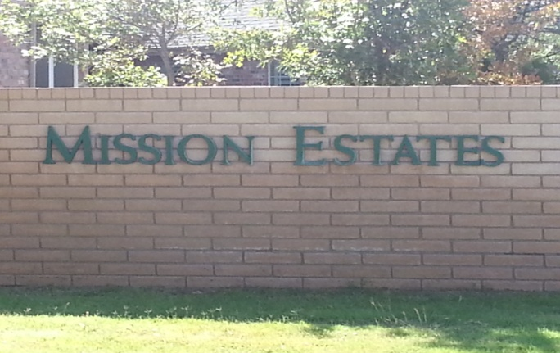 **NEWSLETTER January, 2018**

**MISSION ESTATES PROPERTY OWNERS’ ASSOCIATION**

**From the Board of Directors**

The Board of Directors is charged with upholding the Articles set forth in the Declaration of Covenants, Conditions, and Restrictions (CCR) established by the Mission Estates Property Owners’ Association (MEPOA). Funding for MEPOA is provided from an annual dues assessment. Expenditures include operation, improvement, and maintenance of the Common Properties including water bills, electric bills, sprinkler repairs, fertilization, legal fees, and administrative expenses. The Board members are all volunteers and take their jobs seriously. Any complaint received by the Board of Directors must be addressed according to the guidelines provided in the CCR.

**The most common question the Board receives:**

**What can be done if a homeowner fails to maintain their property?**

Reference**:** *Article VIII, Section 1, and Section 2*

Each Owner and occupant (including any lessee of an Owner) of any part of The Properties shall jointly and severally have the responsibility, at his or their sole cost and expense, to keep that portion of The Properties so owned or occupied, including any Improvements thereon, in a well maintained, safe clean and attractive condition at all times. Such maintenance shall include, but is not limited to, the following:

a. Prompt removal of all litter, trash, refuse and waste.

b. Regular lawn mowing.

c. Tree and shrub pruning.

d. Keeping lawn and garden area alive, free of weeds, and attractive.

e. Watering.

f. Keeping parking areas, driveways and roads in good repair.

g. Complying with all government health and police requirements.

h. Repainting of Improvement.

i. Repair of exterior damage to Improvements.

SECTION 2. *ENFORCEMENT OF MAINTENANCE OBLIGATION*.

If, in the opinion of the Board of Directors of the Association, any such Owner or occupant has failed in any of the foregoing duties or responsibilities, Then the Board of Directors of the Association may give such person written notice of such failure and such Owner or occupant must, within ten (10) days after receiving such notice, perform the care of maintenance required. Should any such Owner or occupant fail to fulfill his duty and responsibility within such period, then the Board of Directors of the Association through its authorized agent or agents shall have the right and power to enter onto the premises and perform such care and maintenance without any liability for damages for wrongful entry, trespass or otherwise to any person. Each Owner and occupant (including lessees) of any part of The Properties on which such work is performed shall be jointly and severally liable for the cost of such work and shall promptly reimburse the Association for such cost. If such Owner or occupant shall fail to reimburse the Association within thirty (30) days after receipt of a statement for such work from the Association, then such indebtedness shall be a debt of all of said Owners and occupants jointly and severally, and shall constitute a lien against that portion of The Properties on which said work was performed. Such lien shall have the same attributes as the lien for assessments set forth in Article III, Section 11 above which provisions are incorporated herein by reference, and the Association shall have identical powers and rights in all respects, including but not limited to, the right of foreclosure in the event of the nonpayment of the indebtedness above described.

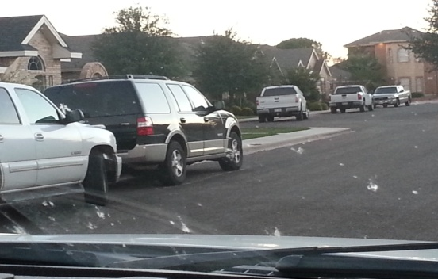

**Can cars be parked in the street?**

Reference:  *Article VI, Section 1. Paragraph F*.

Except as otherwise provided herein, no trailer, mobile home, boat, recreational vehicle, truck larger than 3/4 ton, or vehicle other than passenger automobiles shall be permitted to park over night on any streets located within The Properties.

**What about motor homes or trailers?**

Reference*: Article VI, Section 1. Paragraph G.*

No trailer, mobile home, boat, recreational vehicle, truck larger than ¾ ton, or vehicle other than passenger automobiles shall be parked, maintained, stored or kept on a Lot or Tract unless housed completely within an enclosed structure approved by the Review Board. **Approval of the enclosed structure shall be limited to those designs using materials compatible with the main structure** on the Lot or Tract and which, to the greatest extent possible, conceal the boat, trailer or vehicle from view from any street, golf course or other public areas.

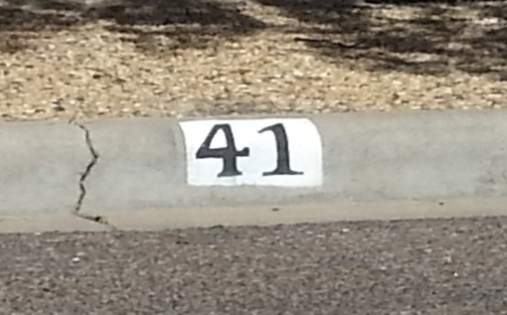

**Can house numbers be painted on the curb?**

Reference*: Article VI, Section 9. Address Identification*

Address numbers shall not be stenciled or printed on any curb, sidewalk, street or driveway. Address numbers shall be displayed as approved by the Architectural Review Board.

**Can storage buildings be placed in yards?**

Reference:*Article VI, Section 1, Paragraph A***.**

No building shall be erected, altered, placed or permitted to remain on any Lot other than one detached single family dwelling and a private garage for not less than two or for not more than four cars. No building shall be erected, altered, placed or permitted to remain on any Tract other than single family detached dwellings, fee simple townhomes, condominiums, cooperative, apartments or other dwellings.

Reference: *Article VI, Section 1, Paragraph C.*

Except as may be otherwise permitted herein, no structure of a temporary character, including, but not limited to, a trailer, recreational vehicle, mobile home, modular home, prefabricated home, tent, shack, barn or any other structure or building (other than the residence to be built thereon) shall be placed on any Lot either temporarily or permanently. No house, garage or other structure appurtenant thereto, shall be moved upon any Lot or Tract from another location.

**Can signs be placed in yards?**

Note: Due to the hail storms that swept our area a number of roofing company signs have been placed in yards. These should be removed as quickly as possible.

Reference**:** *Article VI, Section 8 Signs.*

The Review Board shall have the power to promulgate and enforce rules concerning the placement and maintenance of signs, bill boards, banners, flags and pennants upon any Lot or Tract. No sign, billboard, banner, flag or pennant shall be placed or maintained upon any Lot or Tract except as may be provided in rules to be promulgated by the Review Board.

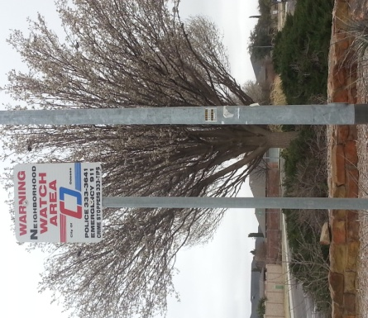

**Security**

The Board of Directors supports the Neighborhood Watch program, but previous efforts to establish a viable program in Mission Estates have failed. Mission Estates is not considered to be a high crime area, and most crimes are those of opportunity. The most common violation is the burglary of vehicles. After much consideration and evaluation, the Board of Directors has retained Paragon Investigative Services to provide nightly random security patrols throughout Mission Estates from 10 pm to 6 am in marked vehicles. Residents are encouraged to have MEPOA stickers on all vehicles, especially if they are to be parked on the street overnight. Contact the Association if you need additional stickers. Other helpful safety tips are as follows:

**Vehicles**

Park in your garage if possible

Lock your vehicle

Do not leave valuables visible in your vehicle

Activate alarms

**Homes**

Use your alarm system and be sure it is registered with OPD

Install security cameras

Install motion lights in dark areas

Leave exterior lighting on at night

Report suspicious activity

Advise your neighbors when you are travelling

If you call 911 let the dispatcher know you live in Mission Estates. A cell number does not have location associated with it and there is a major delay from Midland to Ector County. You can also dial direct to the OPD at **432-333-3641**. All calls require a response.

An armed security system will generate calls to the homeowner and the police when registered with OPD. An officer will respond to an alarm and, by law must clear the residence. They will go in if the door is open to secure your home. A typical response time is 20 to 30 minutes once the alarm is received. If you have a security camera, the OPD has equipment that can enhance your video surveillance to better identify a person or vehicle. OPD encourages homeowners to become familiar with their cameras to be sure how long recordings are held and how to rewind and view for activity.

If you would like to file a report with the Odessa Police Department online the website is [www.odessapd.com](http://www.odessapd.com).

The Midland 911 District number is 684-9911. Their purpose is to assign physical addresses to homes in Midland County. You can contact them to verify your address is registered in their system.

**Note from the Landscape Committee…**

The Board has signed agreements with companies hired to maintain the common areas. If you notice areas in need of attention please notify a Board member or contact the Association.

**From the Architectural Review Board….**

Just a reminder, ***ALL*** plans for modifications or new construction must be presented to the ARB prior to beginning the project. The City of Odessa requires plans be approved by the ARB before issuing a permit. Brad Ward is the ARB Chairman and you may contact him at 432-978-1732.

**The Association does not have jurisdiction over the following:**

* Vehicles being parked on curbs or facing the wrong direction on the street – report to the Odessa Police Department at 333-3641 (non emergency) or 911 (emergency).
* Vandalism and / or speeding – report to the Odessa Police Department at 333-3641 (non-emergency) or 911 (emergency).
* Street lights in need of repair – report to the City of Odessa at 335-3242.
* Alley or street repairs – report to the City of Odessa at 335-3241.
* Problems with animals – report to Animal Control at 368-3526.
* In the spirit of being a good neighbor, please secure any loose or large trash in the alleyways. Each property owner is responsible for maintaining their property to the center of the alleyway. Failure to do so can result in a fine from the City of Odessa.

***JUST A NOTE***

Board meetings are held once a month. If you would like to attend, contact the Association to be informed of the time, place, and be placed on the agenda.

We would like to compile email addresses for all homeowners. This would allow us to reduce the cost of postage and printing for all billing and notices sent to our homeowners. **The emails would be used strictly for the Association and not shared with any entities.** You can send us your email at our website contact link at [www.missionestates.net](http://www.missionestates.net) to [frances@missionestates.net](mailto:frances@missionestates.net)

If you did not receive or have misplaced your copy of the Covenants and Restrictions, you may download them from the website or contact Frances Seely (Administrative Assistant) at 661-2050 or [frances@missionestates.net](mailto:frances@missionestates.net) to receive a hard copy for a fee of $10.00.

**2017-2018 BOARD OF DIRECTORS**

Tim Peden Brad Ward Randy Lewis Lisa Lossin

Lee Emerson Garion Brunson Sylvester John

Contact a Director at our website link at [www.missionestates.net](http://www.missionestates.net)  [or email them at boardofdirectors@missionestates.net](mailto:%20or%20email%20them%20at%20boardofdirectors@missionestates.net)