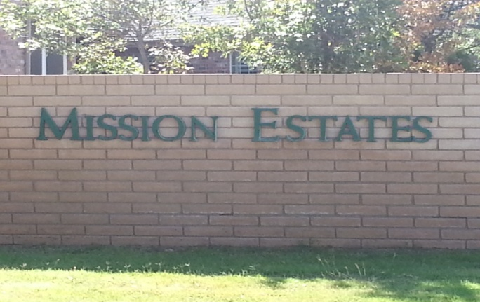 **NEWSLETTER April, 2017**

MISSION ESTATES PROPERTY OWNERS’ ASSOCIATION

**From the Board of Directors**

The Board of Directors is charged with upholding the Articles set forth in the Declaration of Covenants, Conditions, and Restrictions (CCR) established by the Mission Estates Property Owners’ Association (MEPOA). Funding for MEPOA is provided from an annual dues assessment. Expenditures include operation, improvement, and maintenance of the Common Properties including water bills, electric bills, sprinkler repairs, fertilization, legal fees, and administrative expenses. The Board members are all volunteers and take their jobs seriously. Any complaint received by the Board of Directors must be addressed according to the guidelines provided in the CCR.

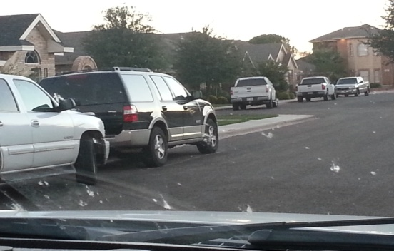

**The most common question the Board receives:**

**Can cars be parked in the street?**

Reference:  *Article VI, Section 1. Paragraph F*.

Except as otherwise provided herein, no trailer, mobile home, boat, recreational vehicle, truck larger than 3/4 ton, or vehicle other than passenger automobiles shall be permitted to park over night on any streets located within The Properties.

**What about motor homes or trailers?**

*Reference: Article VI, Section 1. Paragraph G.*

No trailer, mobile home, boat, recreational vehicle, truck larger than ¾ ton, or vehicle other than passenger automobiles shall be parked, maintained, stored or kept on a Lot or Tract unless housed completely within an enclosed structure approved by the Review Board. Approval of the enclosed structure shall be limited to those designs using materials compatible with the main structure on the Lot or Tract and which, to the greatest extent possible, conceal the boat, trailer or vehicle from view from any street, golf course or other public areas.

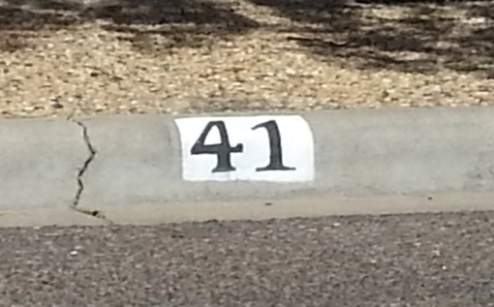

**Can house numbers be painted on the curb?**

*Reference: Article VI, Section 9. Address Identification*

Address numbers shall not be stenciled or printed on any curb, sidewalk, street or driveway. Address numbers shall be displayed as approved by the Architectural Review Board.

**The 11th Filing update**:

As most of you know, a lawsuit was filed in November of 2014 against the Mission Estates Property Owners Association (MEPOA). Subsequently, the parties to the lawsuit have reached a settlement agreement. As part of the settlement agreement all property owners in the 11th Filing of Mission Estates are eligible to receive a portion of the cash settlement.

MEPOA will pay each property owner a pro-rated share of the cash settlement based on the period of ownership beginning June 1, 2013 through May 31, 2016 as follows: Twelve months or less - $300.00, Twenty Four months or less, $600.00, Thirty Six months or more - $900.00. Payments will be credited to any property owner whose MEPOA account is in arrears. Property owners whose MEPOA account is current will receive a cash payment unless they request the payment to be applied to future dues. In addition, all accrued interest, fines, and filing fees for non - payment of dues will be credited and all liens released.

Acceptance of the cash settlement will require (if not already done so) a signing of the Supplemental Declaration of Covenants, Conditions and Restrictions of Mission Estates (Declaration). By signing this Supplemental Declaration, you are agreeing that you understand that your home and/or lot are in the 11th filing of Mission Estates and that you understand that you are obligated to comply with the Covenants and Restrictions of MEPOA and that you are protected by those same Covenants and Restrictions. To request a copy of the Supplemental Declaration please contact MEPOA at [www.missionestates.net](http://www.missionestates.net)

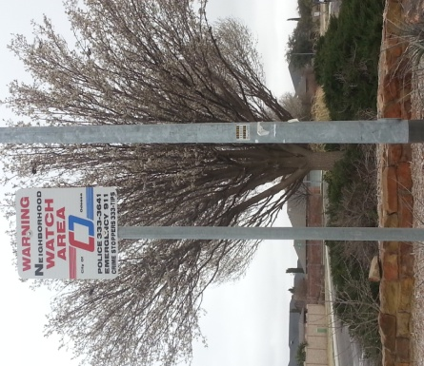

**Security**

The Board of Directors supports the Neighborhood Watch program, but previous efforts to establish a viable program in Mission Estates have failed. Mission Estates is not considered to be a high crime area, and most crimes are those of opportunity. The most common violation is the burglary of vehicles. After much consideration and evaluation, the Board of Directors has retained Paragon Investigative Services to provide nightly random security patrols throughout Mission Estates from 10 pm to 6 am in marked vehicles. Residents are encouraged to have MEPOA stickers on all vehicles, especially if they are to be parked on the street overnight. Contact the Association if you need additional stickers. Other helpful safety tips are as follows:

**Vehicles**

Park in your garage if possible

Lock your vehicle

Do not leave valuables visible in your vehicle

Activate alarms

**Homes**

Use your alarm system and be sure it is registered with OPD

Install security cameras

Install motion lights in dark areas

Report suspicious activity

Advise your neighbors when you are travelling

If you call 911 let the dispatcher know you live in Mission Estates. A cell number does not have location associated with it and there is a major delay from Midland to Ector County. You can also dial direct to the OPD at **432-333-3641**. All calls require a response.

An armed security system will generate calls to the homeowner and the police when registered with OPD. An officer will respond to an alarm and, by law must clear the residence. They will go in if the door is open to secure your home. A typical response time is 20 to 30 minutes once the alarm is received. If you have a security camera, the OPD has equipment that can enhance your video surveillance to better identify a person or vehicle. OPD encourages homeowners to become familiar with their cameras to be sure how long recordings are held and how to rewind and view for activity.

If you would like to file a report with the Odessa Police Department online the website is [www.odessapd.com](http://www.odessapd.com).

The Midland 911 District number is 684-9911. Their purpose is to assign physical addresses to homes in Midland County. You can contact them to verify your address is registered in their system.

**Note from the Landscape Committee…**

Winter pruning of trees and shrubs in the common areas has been completed. Tree removal and grass planting of areas along Mission Drive was completed in the fall of 2016. Landscaping of the Santa Fe and San Jose corner is scheduled for spring of 2017 as well as the North and South traffic islands inside Santa Fe Place. If you notice areas in need of attention please notify a Board member or contact the Association. Other areas to be addressed are the traffic islands along San Jose cul-de-sacs.

**From the Architectural Review Board….**

Just a reminder, ***ALL*** plans for modifications or new construction must be presented to the ARB prior to beginning the project. The City of Odessa requires plans be approved by the ARB before issuing a permit. Brad Ward is the ARB Chairman and you may contact him at 432-978-1732.

**The Association does not have jurisdiction over the following:**

* Vehicles being parked on curbs or facing the wrong direction on the street – report to the Odessa Police Department at 333-3641 (non emergency) or 911 (emergency).
* Vandalism and / or speeding – report to the Odessa Police Department at 333-3641 (non-emergency) or 911 (emergency).
* Street lights in need of repair – report to the City of Odessa at 335-3242.
* Alley or street repairs – report to the City of Odessa at 335-3241.
* Problems with animals – report to Animal Control at 368-3526.
* In the spirit of being a good neighbor, please secure any loose or large trash in the alleyways. Each property owner is responsible for maintaining their property to the center of the alleyway. Failure to do so can result in a fine from the City of Odessa.

***JUST A NOTE***

Board meetings are held once a month. If you would like to attend, contact the Association to be informed of the time, place, and be placed on the agenda.

We would like to compile email addresses for all homeowners. This would allow us to reduce the cost of postage and printing for all billing and notices sent to our homeowners. The emails would be used strictly for the Association and not shared with any entities. You can send us your email at our website contact link at [www.missionestates.net](http://www.missionestates.net) to [frances@missionestates.net](mailto:frances@missionestates.net)

If you did not receive or have misplaced your copy of the Covenants and Restrictions, you may download them from the website or contact Frances Seely (Administrative Assistant) at 661-2050 or [frances@missionestates.net](mailto:frances@missionestates.net) to receive a hard copy for a fee of $10.00.

**2016-2017 BOARD OF DIRECTORS**

Jim Brown Brad Ward Randy Lewis Frances Reedy

Tim Peden Kurt Verlei James Gilliland

Contact a Director at our website link at [www.missionestates.net](http://www.missionestates.net)  [or email them at boardofdirectors@missionestates.net](mailto:%20or%20email%20them%20at%20boardofdirectors@missionestates.net)